31.Write a Python program to create a stacked bar plot with error bars.
Aim:
To write a Python program to create a stacked bar plot with error bars using Matplotlib.
Program:
import matplotlib.pyplot as plt
categories = ['A', 'B', 'C', 'D']
values1 = [20, 30, 25, 35]
values2 = [15, 20, 30, 25]
errors = [2, 3, 2, 4]
plt.bar(categories, values1, label='Group 1')
plt.bar(categories, values2, bottom=values1, label='Group 2',
yerr=errors, capsize=5)
plt.xlabel('Categories')
plt.ylabel('Values')
plt.title('Stacked Bar Plot with Error Bars')
plt.legend()
plt.show()
Output:
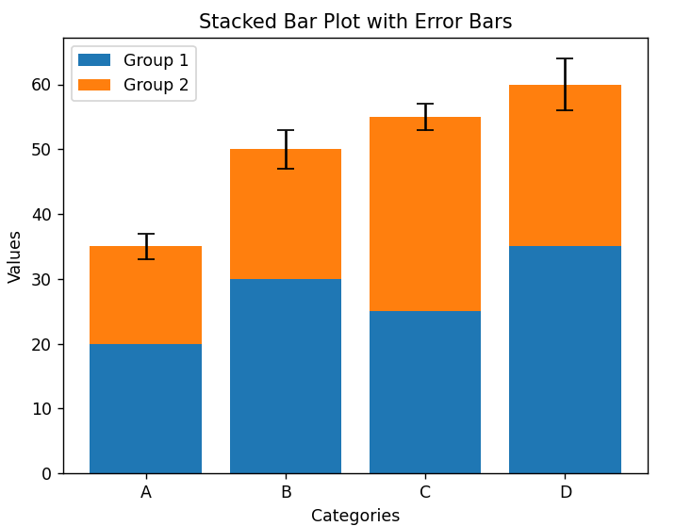
Result:
Thus, the Python program to create a stacked bar plot with error bars was successfully executed.

32.Write a Python program to draw a scatter graph taking a random distribution in X and Y and plotted against each other.
Aim:
To write a Python program to draw a scatter graph using randomly generated values for X and Y and plot them against each other.
Program:
import matplotlib.pyplot as plt
import numpy as np
x = np.random.rand(50)
y = np.random.rand(50)
plt.scatter(x, y)
plt.xlabel('X Values')
plt.ylabel('Y Values')
plt.title('Scatter Plot of Random X and Y Values')
plt.show()
Output:
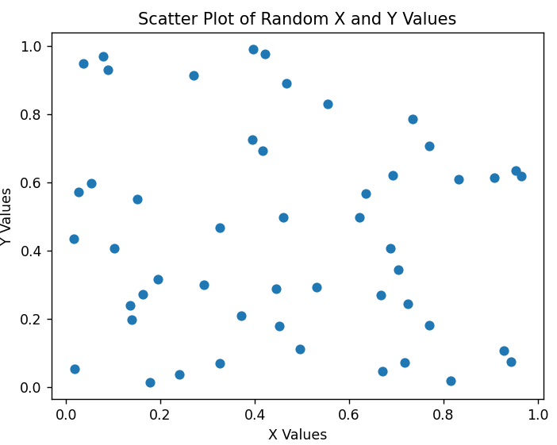
Result:
Thus, the Python program to draw a scatter graph using random X and Y values was successfully executed.

